# **Must Know Linux/Unix Commands**

File Management becomes easy if you know the right commands.

Sometimes, commands are also referred as "programs" since whenever you run a command, actually, it's the corresponding program code, written for the command, which is being executed.

Let's learn the must know Linux commands.

### **Listing files (ls)**

If you want to see the list of files on your UNIX or Linux system, use the '**ls'** command.

It shows the files /directories in your current directory.

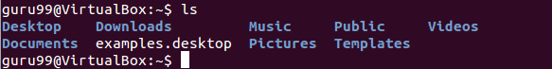

Note:

* Directories are denoted in blue color.
* Files are denoted in white.
* You will find similar color schemes in different flavors of Linux.

Suppose, your "Music" folder has following sub-directories and files.

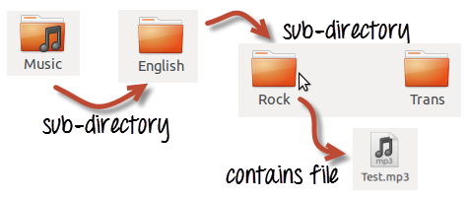

You can use **'ls-R' to shows all the files not only in directories but also subdirectories**

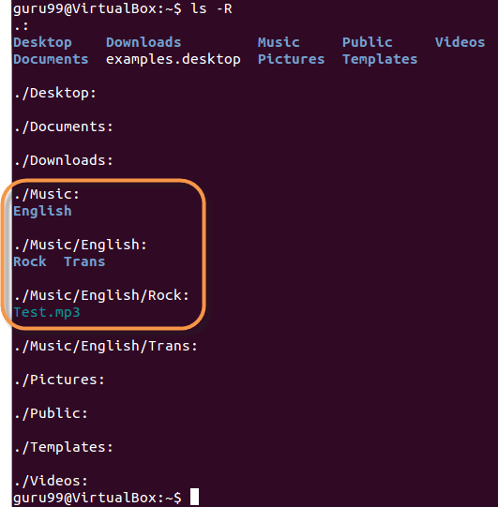

NOTE: The command is case-sensitive. If you enter, "**ls - r**" you will get an error

**'ls -al'** gives detailed information of the files. The command provides information in a columnar format. The columns provide the following information:

|  |  |
| --- | --- |
| **1st Column** | **File type and access permissions** |
| **2nd Column** | # of HardLinks to the File |
| **3rd Column** | Owner and the creator of the file |
| **4th Column** | Group of the owner |
| **5th Column** | File size in Bytes |
| **6th Column** | Date and Time |
| **7th Column** | Directory or File name |

Let's see an example -

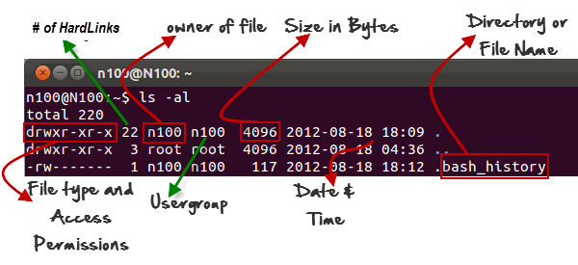

### **Listing Hidden Files**

Hidden items in UNIX/Linux begin with -Must Know Linux/Unix Commandsat the start, of the file or directory.

Any Directory/file starting with a '.' will not be seen unless you request for it. To view hidden files, use the command

***ls - a***

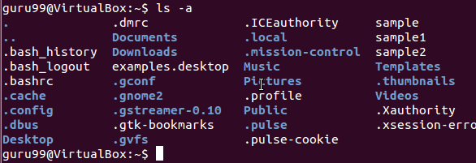

### **Creating & Viewing Files**

The 'cat' command is used to display text files. It can also be used for copying, combining and creating new text files. Let's see how it works

To create a new file, use the command

1. cat > filename
2. Add content
3. Press 'ctrl + d' to return to command prompt.

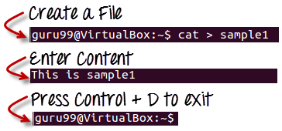

To view a file, use the command -

cat

Let's see the file we just created -

Must Know Linux/Unix Commands

Let's see another file sample2

Must Know Linux/Unix Commands

The syntax to combine 2 files is -

***cat file1 file2 > newfilename***

Let's combine sample 1 and sample 2.

Must Know Linux/Unix Commands

As soon as you insert this command and hit enter, the files are concatenated, but you do not see a result. This is because **Bash Shell (Terminal) is silent type**. It will never give you a confirmation message like "OK" or "Command Successfully Executed". It will only show a message when something goes wrong or when an error has occurred.

In order to view the new combo file "sample" use the command

***cat sample***

Must Know Linux/Unix Commands

**Note:** Only text files can be displayed and combined using this command.

### **Deleting Files**

The 'rm' command removes files from the system without confirmation. To delete a file use syntax -

***rm***

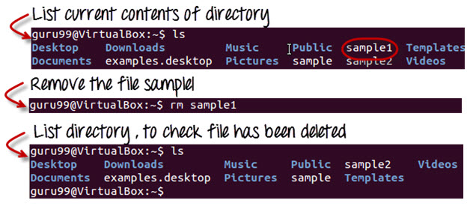

### **Moving and Re-naming files**

In order to move a file, use the command

***mv***

Suppose we want to move the file "sample2" to location /home/guru99/Documents. Executing the command

***mv sample2 /home/guru99/Documents***

Must Know Linux/Unix Commands

mv command needs super user permission. Currently, we are executing the command as a standard user. Hence we get the above error. To overcome the error use command

***sudo***

Sudo program allows regular users to run programs with the security privileges of the superuser or root.

Sudo command will ask for password authentication. Though, you do not need to know the root password. You can supply your own password. After authentication, the system will invoke the requested command.

Sudo maintains a log of each command run. System administrators can trackback the person responsible for undesirable changes in the system

Must Know Linux/Unix Commands

For renaming file:

***mv filename newfilename***

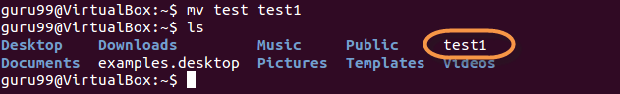

**NOTE**: By default, the password you entered for sudo is retained for 15 minutes per terminal. This eliminates the need of entering the password time and again.

You only need root/sudo privileges, only if the command involves files or directories not owned by the user or group running the comman

## **Directory Manipulations**



Enough with File manipulations! Let's learn some directory commands

Creating Directories

Directories can be created on a Linux operating system using the following command

***mkdir***

This command will create a subdirectory in your present working directory, which is usually your "Home Directory".

For example,

***mkdir mydirectory***

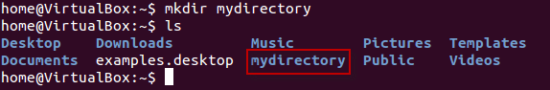

If you want to create a directory in a different location other than 'Home directory', you could use the following command -

***mkdir***

For example:

***mkdir /tmp/MUSIC***

will create a directory 'Music' under '/tmp' directory

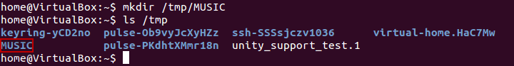

You can also create more than one directory at a time.

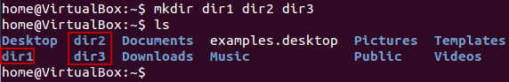

## **Removing Directories**

In order to remove a directory, use the command -

***rmdir***

Example

***rmdir mydirectory***

will delete the directory mydirectory

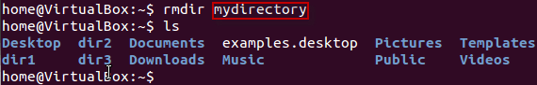

**Tip**: Ensure that there is no file / sub-directory under the directory that you want to delete. Delete the files/sub-directory first before deleting the parent directory.

Must Know Linux/Unix Commands

## **Renaming Directory**

The 'mv' (move) command (covered earlier) can also be used for renaming directories. Use the below given format:

***mv directoryname newdirectoryname***

Let us try it:

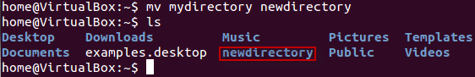

## **Other Important Commands**

### **The 'Man' command**

Man stands for manual which is a reference book of a Linux operating system. It is similar to HELP file found in popular softwares.

To get help on any command that you do not understand, you can type

***man***

The terminal would open the manual page for that command.

For an example, if we type *man man* and hit enter; terminal would give us information on man command

Must Know Linux/Unix Commands

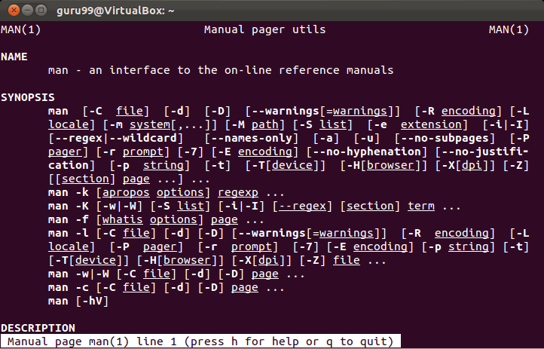

### **The History Command**

History command shows all the commands that you have used in the past for the current terminal session. This can help you refer to the old commands you have entered and re-use them in your operations again.

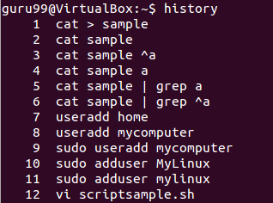

### **The clear command**

This command clears all the clutter on the terminal and gives you a clean window to work on, just like when you launch the terminal.

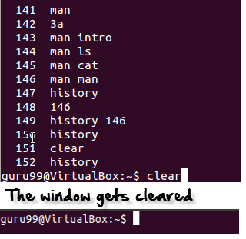

## **Pasting commands into the terminal**

Many a times you would have to type in long commands on the Terminal. Well, it can be annoying at times, and if you want to avoid such a situation then copy, pasting the commands can come to rescue.

For copying, the text from a source, you would use **Ctrl + c,** but for pasting it on the Terminal you need to use **Ctrl + Shift + v**. You can also try **Shift + Insert or select Edit>Paste on the menu**

## **Summary**



Below is a summary of commands we have learned in this tutorial

|  |  |
| --- | --- |
| Command | Description |
| ls | Lists all files and directories in the present working directory |
| ls - R | Lists files in sub-directories as well |
| ls - a | Lists hidden files as well |
| ls - al | Lists files and directories with detailed information like permissions , size , owner etc. |
| cat > filename | Creates a new file |
| cat filename | Displays the file content |
| cat file file2 > file3 | Joins two files (file1, file2) and stores the output in a new file (file3) |
| mv file "new file path" | Moves the files to the new location |
| mv filename new_file_name | Renames the file to a new filename |
| sudo | Allows regular users to run programs with the security privileges of the superuser or root |
| rm | Deletes a file |
| man | Gives help information on a command |
| history | Gives a list of all past commands typed in the current terminal session |
| clear | Clears the terminal |
| mkdir | Creates a new directory in the present working directory |
| mkdir | Create a new directory at the specified path |
| rmdir | Deletes a directory |
| mv | Renames a directory |